Docker
1.Create instace and connect to tirminus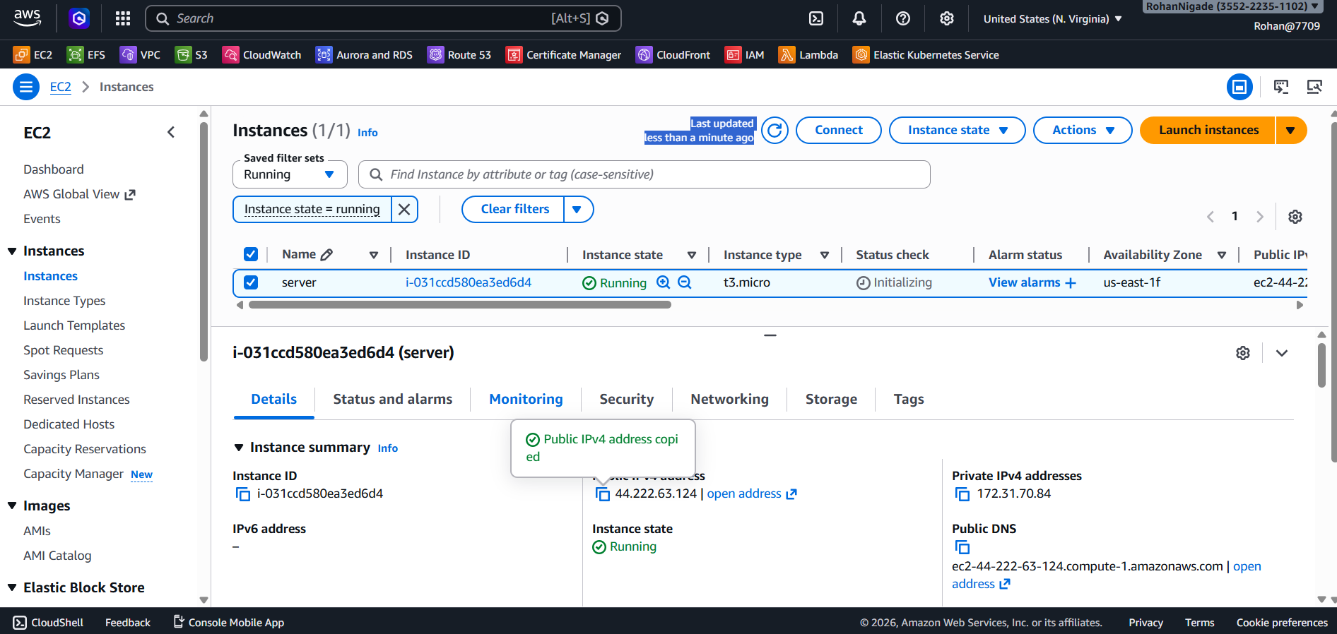
2.Install Docker and start the docker
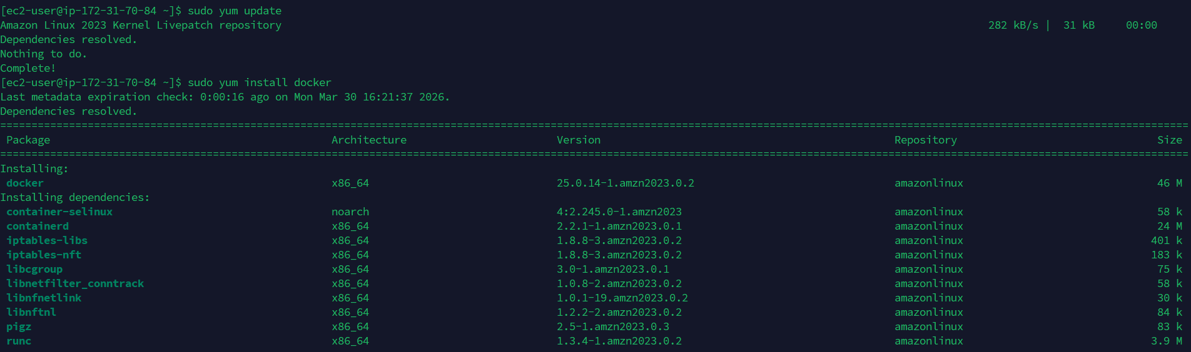
3.Add user in docker group and get permission to it and pull the image from dockerhub
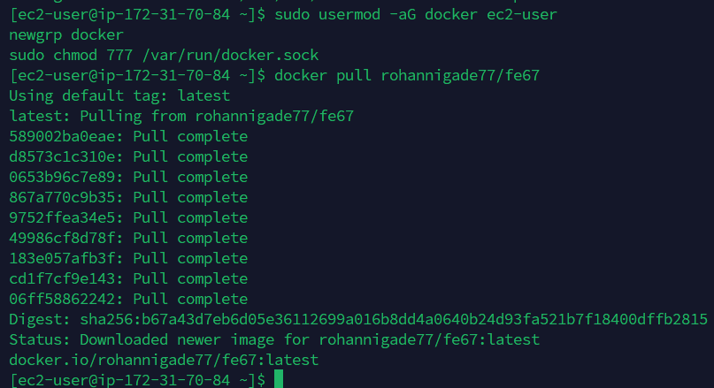

6 Check the docker images and run it in container and check it
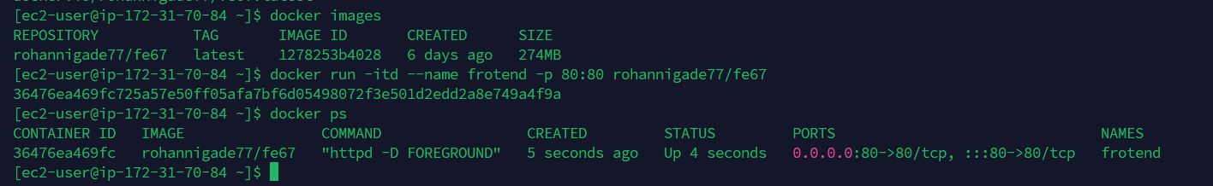
7. Add port number in security group and copy the instace id and check it
